CST 326 – Game Development

Project 1 - PONG (Part 1)

California State University Monterey Bay

Check out the history of Pong (~36 min), some great computer science topics and game topics … and ‘just figuring it out’

History of Pong Pt.1 - <https://youtu.be/QKBrnQwcyXQ>

History of Pong Pt.2 - <https://www.youtube.com/watch?v=yVvKFcIHoWQ>

History of Pong Pt.3 - <https://youtu.be/e1p9a0QOWwI>

Objective:

We will learn to create the game that created the arcade/video game landscape. Pong. The first iteration of the game took about a week and a half, ironically, you will have about the same.

We will create a Unity project and use version control in BitBucket or GitHub. You will add myself (SeaFog) as a member of your team in BitBucket, or [hookslap@gmail.com](mailto:hookslap@gmail.com) if you are using GitHub.

SUBMISSION: FORMAT AND RULES

(Part 1) You have until Sunday, 11:59:30 PM to upload solution for Project 1. “Uploading” consists of sending the url for the download of your latest commit on the project.

(Part 2) You have until class starts, February 3rd, to upload the link from your screen captured video (should be an ‘unlisted’ video in YouTube in your profile) with you explaining your code (should be <5 minutes). Alternatively, you can explain your code in person to me in class (again <5 minutes).

**Starting Assets: (import package)**

[**https://drive.google.com/file/d/10ZzaGegiqZ5LFra11u5cLJz5G_ax6X8S/view?usp=sharing**](https://drive.google.com/file/d/10ZzaGegiqZ5LFra11u5cLJz5G_ax6X8S/view?usp=sharing)

The total value of this activity: 40 bonus points (up to 50 with extra credit)

Implement the following in your game:

(10 Points) Implement control scheme Pong. “Two players”, two different sets of keys (‘up’ and ‘down’) for each player to control paddles.

---------- Approaches ----------

* 5 points, if the keys are assigned in a script that is attached to each paddle.
* 7 points, if you reference the Input Manager in Project Settings (screenshot below) to controls each paddle separately.

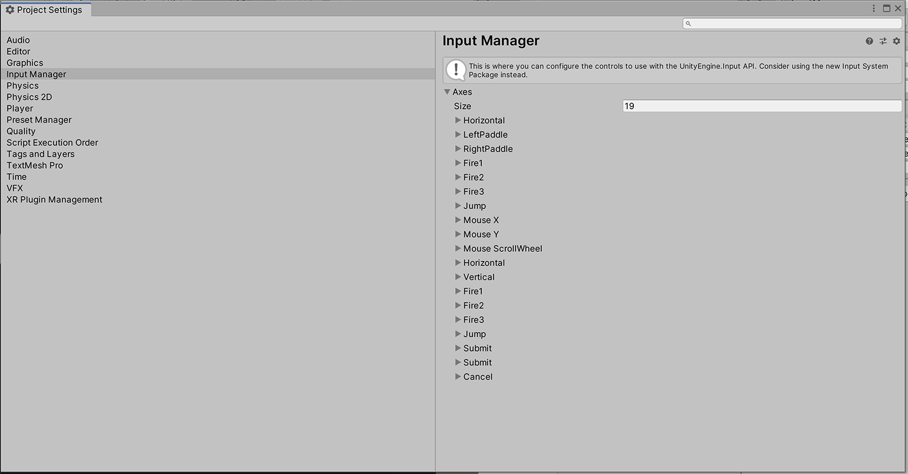

---------- Additional -----------

* 3 points, if you reference both paddles in one 'manager' class that manages both

(10 Points) Ball Behavior

---------- Approaches ----------

* 5 points, if only using a physics material on the ball to make it bounce off paddles
* 7 points, if you are using the collision to give the ball a predictable trajectory

---------- Additional -----------

* 2 points, if you increment the speed every time the paddle hits the ball during one play (resets after a goal)
* 1 point, if when it starts it sends the ball to the player that just got “scored on”

(10 Points) Scoring

* 5 points, Keep track of scoring from each player
* 3 points, Write to console each time a player scores, who scored, and what the score is
* 2 point, Writing “Game Over, [Left or Right] Paddle Wins” to the console and resetting the score to 0-0 when one player hits 11 point

(10 Points) Talking Through your project

* Talk about your project, point by point in the formats discussed in class
* You get 1 point for turning something in a video (or talking with me in class) and 3 points for each section (Input, Ball Behavior and Scoring) you discuss for a total of 10 points.

-------------

(extra credit) (Up to 10 points) Make Pong 'Juicy'

* Have to be able to describe what you’ve done
* Examples with complexity:
  + 3 points if you change a property of the material when the ball gets hit
  + 5 points incorporate a particle system trail

Examples :

<https://www.youtube.com/watch?v=Fy0aCDmgnxg>

<https://www.youtube.com/watch?v=WfwRBwNz2bg>

(UI and Sound next week)